Title: Multiple Sequence Alignment of Telomerase Reverse transcriptase (TERT) Protein Family Using Clustal Omega.
Introduction: Telomerase reverse transcriptase (TERT) is an essential catalytic subunit of telomerase responsible for maintaining chromosome stability and telomere length. Multiple Sequence Alignment (MSA) was performed to analyze conserved regions and evolutionary relationships among TERT proteins from different organisms.
Objective:
- To perform Multiple Sequence Alignment of TERT proteins.
- To identify conserved motifs and amino acid residues.
- To study sequence similarity among species.
Tools Used: -
Tools | Purpose
Clustal Omega | Sequence alignment
UniProt | Sequence retrieval

Protein Sequences Used: -
Protein | Organism
TERT-HUMAN | Homo sapiens
TERT-MOUSE | Mus musculus
TERT-RAT | Rattus norvegicus

Methodology:
Step 1 – Open Clustal Omega
Go to:
https://www.ebi.ac.uk

Step 2- Paste Sequences
Paste the FASTA sequence that I provided into the input box.

Step 3-Run Alignment
Click: Submit
The multiple sequence alignment will be automatically generated upon submission.

Results and Figures (recommended):
1.FASTA Protein Sequences of TERT Family Used for Multiple Sequence Alignment:
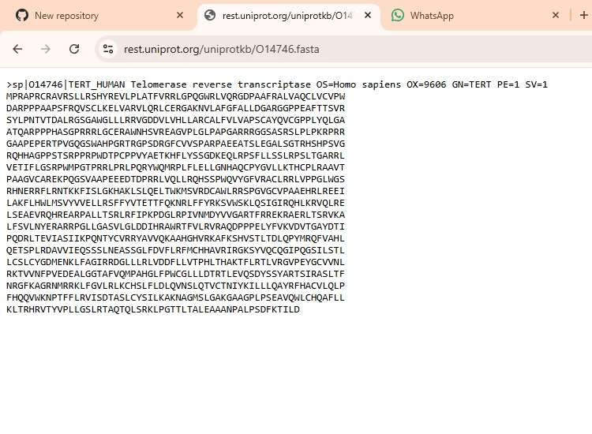
Figure 1A: FASTA sequence of TERT_HUMAN
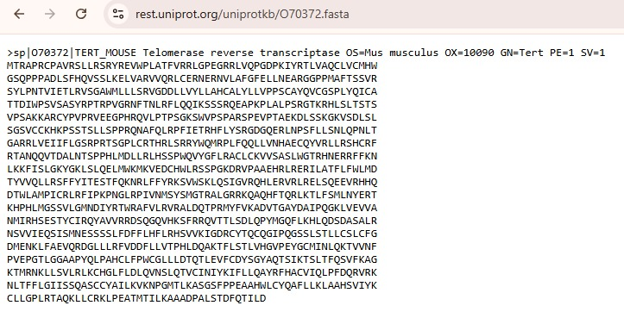
Figure 1B: FASTA sequence of TERT_MOUSE.

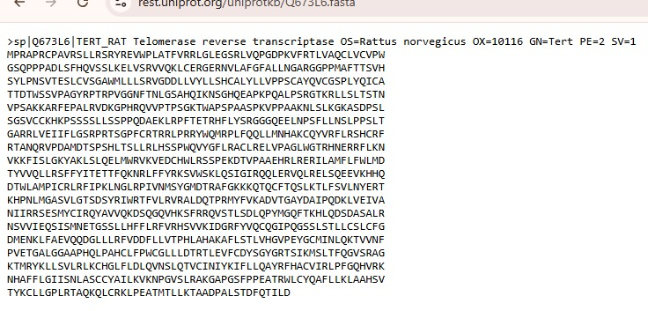
Figure 1C: FASTA sequence of TERT_RAT.
Explanation: The figure represents FASTA formatted amino acid sequence of telomerase Reverse Transcriptase (TERT) proteins obtained from homo sapiens (human), Mus musculus (mouse), and Rattus norvegicus (rat). These sequences were retrieved from UniProt database and used for Multiple Sequence Alignment analysis. The combined dataset allows comparison of conserved regions and sequence similarities among different mammalian species, helping to understand evolutionary conservation of the TERT protein.
2. Clustal Omega input interface:
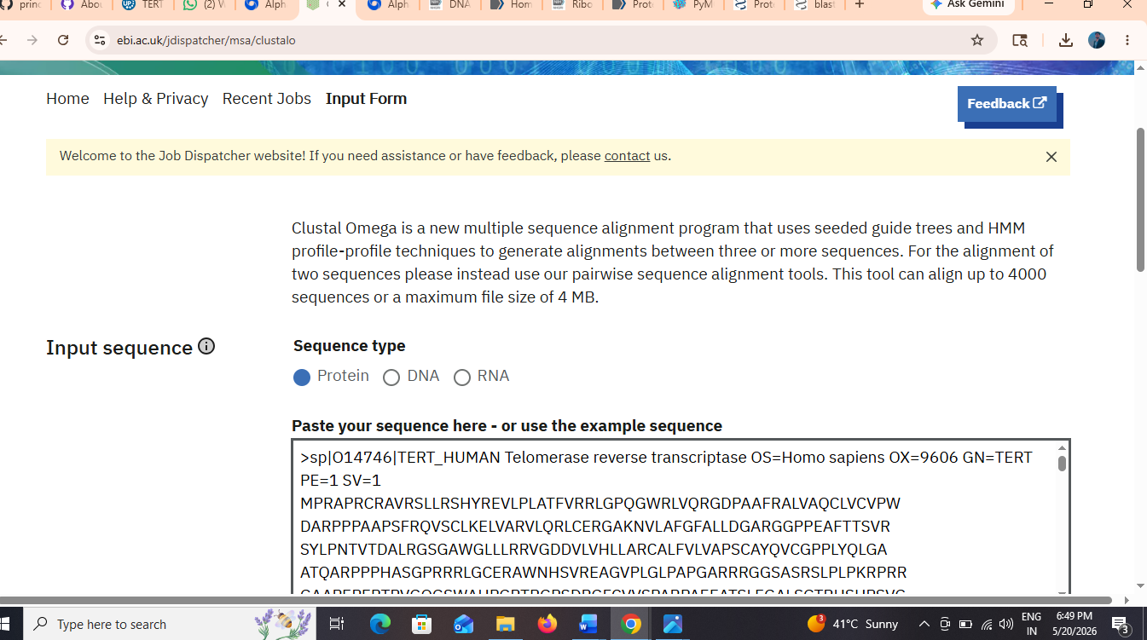
Figure 2: Sequence Submission in Clustal Omega.
Explanation: Protein sequence Were uploaded into the Clustal Omega interface for alignment analysis.

3. Final Alignment Result.
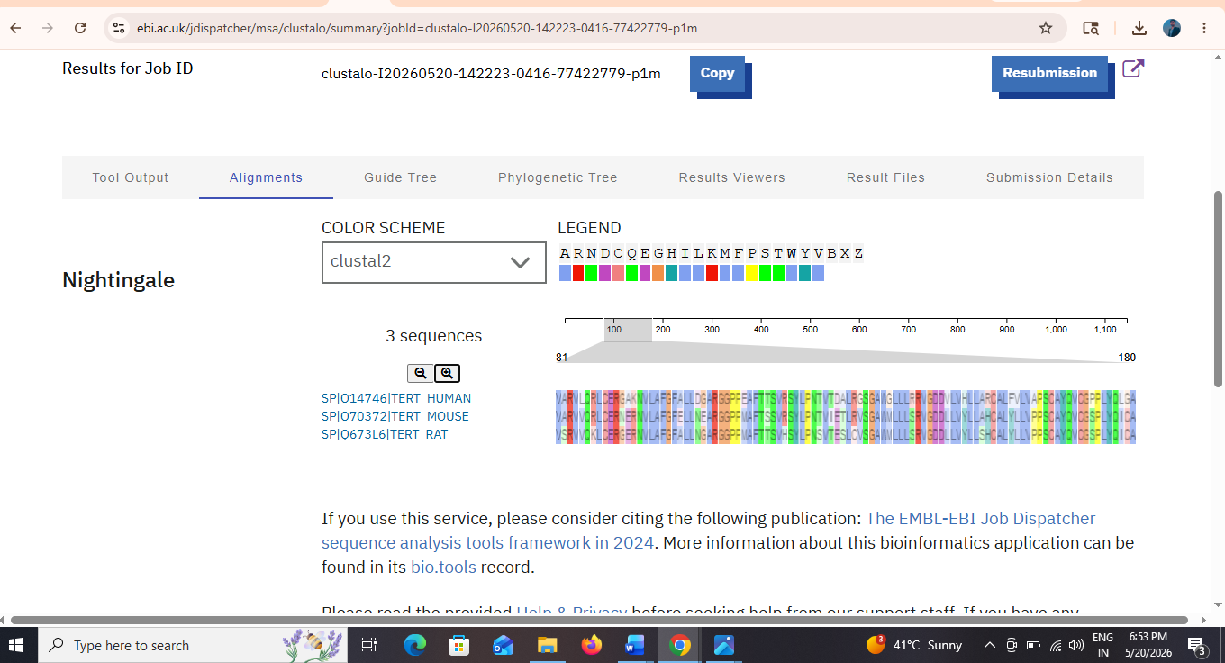
Figure 3: Multiple Sequence Alignment Output of TERT Proteins.
Explanation: The alignment result demonstrates conserved amino acid residues and sequence similarity among TERT proteins from different organisms.
Conserved Regions: Several conserved residues marked with “*” were observed in the alignment output, indicating highly conserved functional domains among TERT protein.
Symbol | Meaning
* | Fully conserved
: | Strong similarity
. | Weak similarity
Interpretation: The MSA analysis revealed high sequence similarity among human, mouse, and rat TERT protein. Conserved regions indicate functional importance and evolutionary conservation of telomerase reverse transcriptase proteins. Minor variations may reflect species-specific adaptations.

Conclusion: Multiple Sequence alignment successfully identified conserved motifs and amino acid regions within TERT Proteins. The study confirmed evolutionary relationships and structural conservation among selected species.
References:
- https://www.uniprot.org
- https://www.ebi.ac.uk
- ncbi.nlm.nih.gov

